1. **Program to create, read and display the array using literal and constructor.**

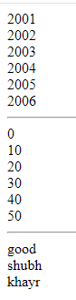var years = [2001,2002,2003,2004,2005,2006]; //literal

var arr = new Array(6); //constructor

var arr2 = ['good','shubh','khayr'];

for(let year of years){

document.write(year + "<br>");

}

document.write("<hr>");

for(let i=0;i<6;i++){

arr[i] = i*10;

document.write(arr[i] + "<br>" );

}

document.write("<hr>")

for(let i=0;i<arr2.length;i++){

document.write(arr2[i] + "<br>");

}

1. **Write a program to sort an array.**
2. **Write a program to print the length of array.**

var years = [2001,2002,2003,2004,2005,2006]; //literal

****console.log("Length of array : "+ years.length);

1. **Write a program to display sparse array.**

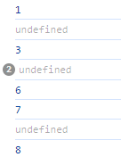var sparseArray = [1,,3,,,6,7,,8];

for(let num of sparseArray){

console.log(num);

}

1. **Write a program to show the usage of splice method.**

let arr = [10,20,30,40,50,60];

console.log("Original Array : " + arr);

arr.splice(2,0,25,27);

console.log("After splicing (2,0,25,27) : " + arr);

arr.splice(2,2);

console.log("Again splicing (2,2) : " + arr);

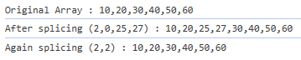

1. **Write a program to insert element in an array using different method.**

let arr = [10,20,30,40,50,60];

console.log("Original Array : " + arr);

arr.push(70,80,90);

console.log("Inserting at end using push : ", arr);

arr.unshift(0,5);

console.log("Inserting at start using unshift : ", arr);

arr.splice(6,0,47);

console.log("Inserting in between using splice : ", arr);

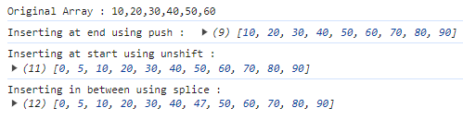

1. **Write a program to delete the element from the array using different method.**

let arr = [10,20,30,40,50,60];

console.log("Original Array : " + arr);

arr.pop();

console.log("Deleting at end using pop : ", arr);

arr.shift();

console.log("Deleting at start using shift : ", arr);

arr.splice(1,2);

console.log("Deleting in between using splice : ", arr);

